FRIARS PRIMARY (FOUNDATION) SCHOOL

Attendance and Register Policy
Agreed Policy



Review Date |  | March 2023
Review Cycle |  | 2 Years
Agreed by Governing Body (Achievement S/C) |  | 5th February 2025
Review Date |  | February 2027
Signed by Chair of Committee | Name |  | Date

Friars Primary (Foundation) School

Attendance policy and procedures for registration of pupils September 2024

General
Children with good attendance do better in school and often find it easier to make friends. It is also vital for their educational progress, well-being and for their wider development. We expect all children to attend each day unless they are ill. There is a legal duty for parents of children of compulsory school age to send their children to school regularly.
Our attendance target for the whole school is 97%. The National expectation is that children’s attendance is 96% or better.
We expect children to arrive at school on time. The school gates are open from 8.45am until 9.00am to allow a staggered start for families. Any child arriving after 9.00am will be marked as late. Children arriving later than 9.30am without a good reason are not given an attendance mark, although their presence is recorded in the register as an unauthorised late.
We acknowledge good attendance and punctuality and the class with the best weekly attendance and punctuality receives a certificate in assembly. Attendance is reported in the weekly school newsletter. Each half term children with 100% attendance receive a coloured wristband and a sticker for 100% punctuality for that half term. At the end of the academic year children with 100% for the whole year will receive a 100% attendance badge.

Parents’ Responsibilities
It is your duty under the Education Act 1996 (section 444) to ensure your child attends school regularly. Failure to adhere to this could lead to a prosecution and a fine of up to £2500 or a prison sentence.
Parents are aware through the Home School Agreement of their responsibilities for getting their children to school on time, every day.
Specifically, parents should:
- Inform the school in advance if they expect a child to be absent for any reason
- Inform the school if they need to pick their child up from school early
- Contact the school on the first day of absence, usually by phone or using the StudyBug App, to report their absence. They should do this before 09:30am.
- Send a note giving the reasons for absence when a child returns to school (if they omitted to contact the school beforehand)
- Telephone the school if they are unavoidably delayed in picking up a child from school
- Make sure the school has the correct addresses and phone numbers
- Ensure the school has names, addresses and phone numbers of at least 3 people who can be contacted in an emergency

Term-time or special leave
- If parents are requesting term-time or special leave they must complete a request form which is considered by the Leadership Team.
- The law in regards to term-time holiday states that parents do not have the right to take their child out of school for holidays during term time. All requested leave during term time must be discussed and agreed with the Leadership Team and in exceptional circumstances a short period of absence may be agreed. It is not a right.
- The Southwark Education Inclusion Team supports its schools in discouraging term time leave absences.
- If the request is not authorised a warning letter will be issued and a copy will be placed in the child’s record folder. The absence will be marked as an unauthorised absence.
- Any parent who takes a child out of school for term time leave of 10 or more morning and afternoon sessions during any 100 school sessions or 50 school days, not authorised by the school may receive a penalty notice.
- The unauthorised term time leave does not have to be consecutive for a parent to receive a penalty notice. In deciding whether to refer a case for the sanction of a penalty notice we will take into account whether there is any known evidence of previous unauthorised term time leave taken in the last 3 years and parents having previously been warned about a potential penalty notice.
- The school can off roll your child if they have been gone for 20 consecutive days.

persistent absence
- We offer support from our Inclusion Manager or Leadership Team to families who are finding getting to school every day or on time difficult or for children who are persistent absentees and may be at risk of becoming disillusioned with education or school refusers.
- All children whose attendance is below 90% are discussed. A warning letter is sent notifying parents that this is the case and their child’s attendance is being closely monitored. The letter also states the days/sessions missed in numbers, as well as time lost and the opportunity for parents to come in and discuss this will be offered. Parents may be invited to an initial virtual or in person meeting if their child’s attendance doesn’t improve.
- Where families are working with Children’s Social Care or Family Early Help, the child/ren’s social worker or family early help practitioner is responsible for taking action and following up on attendance concerns, including liaising with the school.
- Where attendance is an ongoing concern, a TAF may be convened including any other professionals involved with the family. Targets will be set with a clear period in which attendance will be monitored and reviewed.
- If we continue to be concerned about a child’s attendance we may seek further advice from the Education Inclusion Duty Team. Senior Education Welfare Officers (SEWOs) are available to support with advice and next steps.
- No improvement in attendance could lead to a SEWO becoming involved. An attendance and inclusion team meeting will be held. A formal agreement will be entered into via an education parenting contract. At this point, the SEWO will decide whether a formal written “Notice of Attendance Concern” will be issued to the parent to inform them that they are at risk of legal action.
- No improvement could lead to statutory attendance (legal) action being taken.
- Any child who is late after 9.15am more than 10 times in a term will be discussed. A letter is sent notifying parents that this is the case and their child’s punctuality is being closely monitored. The letter also states the amount of time lost. Reward charts are put in place for those children who are persistently late.
Procedures in cases of unexplained absence
- Parents are expected to call the school office on the first day of absence to report their absence before 9.30am. A text message will be sent to remind parents.
- If we have not heard from the parent by 10a.m. the administrator for attendance will start to call all the contact numbers provided in order to gain an explanation for the absence. Any contacts outside of the family will be contacted if we haven’t had a reply by 12pm.
- The administrator for attendance will send the parents a text message notifying them that if we are unable to make contact and gain a reason for absence by midday then we may make a home visit (2 members of staff including a member of the safeguarding team).
- If a child is unwell, then parents must report their absence daily until they return. In the case of a longer-term illness, then this can be discussed with the office.
- If we are still unable to get a response then, depending on the concerns, we will report it to Early Help, the MASH team or to the police as a “missing child.”

Staff Responsibilities

Leadership Team
The Leadership Team have responsibility for attendance and punctuality in school and for passing information on attendance to Southwark Education and the DfE. The Designated Safeguarding leads have responsibility for informing Social Services if any child with a social worker is absent.
A member of the Leadership Team interviews prospective parents and in the course of this meeting, points out parental responsibilities outlined in the school’s Home School Agreement. This includes attendance and punctuality.
The member of the Leadership Team responsible for attendance tracks children who are persistently absent and analyses attendance data termly to look for patterns and identify further ways to improve whole school attendance and target those persistent absentees. The Inclusion Team meets with the Family Early Help Service locality team linked to the schools once or twice a term for a Team Around the School meeting (TAS). Key families causing concern are discussed. A member of the Safeguarding team is on the gate every morning to note down those children who arrive late.

Administrator in charge of Attendance
The Administrator is delegated by the Headteacher for matters of attendance and punctuality and to ensure registers are kept up to date. They have day to day responsibility for dealing with matters of pupil enrolment and change of school. This includes the upkeep of all pupil paper records and computer data bases. The Administrator, in consultation with the Deputy Head or Headteacher, is able to take children “off-roll”.
- Taking telephone messages about pupil absence and recording details on data base
- Filling in children’s names and time of arrival in school
- Printing off and filing a daily attendance sheet to use in the event of an emergency
- Keeping the school attendance data up to date
- Phoning parents on the first day or unexplained absence (see first day contact procedures above)
- Contacting parents if children are left in school after the school day ends
- Contacting parents to discuss unauthorised absences
- Recording on the data base the time, date and information received through phone calls, meetings, or written answers to letters
- Checking e-registers every week and ensuring teachers are aware of how to complete them correctly
- Working out weekly statistics for the award of the class weekly attendance certificate
- Working out percentage attendance figures for the school and all classes
- Liaising with the member of the Leadership Team or Attendance Officer

Family Liaison/Attendance Officer
The Family Liaison/Attendance Officer is delegated by the Headteacher to work alongside the Inclusion Leader, to deal with pupil attendance matters. They have responsibility for:
- monitoring attendance and punctuality
- working with families to improve attendance and punctuality
- to work with multi agencies involved in persistent absences
- to promote attendance/punctuality to reduce the overall impact on children’s learning
- to report any concerns and provide details

Teachers and Teaching Assistants
Class teachers and assistants have responsibility for day to day monitoring of attendance and the upkeep of e-registers. Specific duties include:
- Marking e-registers at the start of the morning sessions according to the stated procedures
- Ensuring that children arriving late report to the Office so they can be marked in as present in school
- Notifying office staff of any known reason for absence and lateness if these are given by parents
- Informing the school’s designated safeguarding leads as soon as possible about any concerns
- Informing the Leadership Team and Administrator if they have any information about a child leaving the school

Family Early Help Service

Following the restructure of early help services in Southwark in 2018, all schools have a dedicated Family Early Help (FEH) single point of contact (SPOC) who meets with each school on a termly basis to identify children who meet the threshold for statutory education intervention from the local authority, and to agree whether such action will be taken. In addition, trading and maintained primary and secondary schools benefit from a significantly expanded offer of a full Team Around the School (TAS) meeting. This meeting provides an opportunity to explore and plan interventions to reduce the negative impact of wider adverse childhood experiences that affect a child or young person’s ability to learn and achieve, including parental mental or physical ill-health, domestic abuse, substance misuse, parental conflict or financial exclusion and agree the most appropriate multi-agency response to these.
Although the SPOC does not hold ultimate responsibility for the coordination and delivery of services for children whose attendance or behaviour at school is poor, schools are strongly encouraged to use the SPOC and TAS frameworks to work proactively with the local authority. This will help ensure that we collectively identify young people who have poor school attendance or are at risk of exclusion at the earliest opportunity and that help and support is provided at the right time and at the appropriate threshold of need.

Children at risk of Missing Education (CME) (2016)
Friars has in place appropriate safeguarding responses for children who go missing from school, particularly on repeat occasions. Where reasonably practicable, for every pupil, we hold an emergency contact number for more than one person, ideally at least three per child/family. Emergency contact numbers are provided and updated by the parent with whom the pupil normally resides. This is recommended practice and by doing so provides us with additional options for making contact with a responsible adult when a child is missing from school and is also identified as a welfare and/or safeguarding concern.

Where school staff have concerns about a child, they report this immediately to the Designated Safeguarding Lead who then uses their professional judgement and knowledge of the individual pupil to inform their decision as to whether welfare concerns should be escalated. The local authority have a duty to put in place arrangements for identifying (as far as it is possible) those children of compulsory school age in their area who are not school registered or receiving suitable education otherwise than at a school. The local authority should trace those children and ensure that they receive full-time education.

We will notify the local authority when a pupil’s name is to be deleted from the admission register under any of the grounds prescribed in regulation 8 of the Education (Pupil Registration) (England) Regulations 2006 as amended, as soon as the ground for removal is met and no later than the time at which the pupil’s name is removed from the register. This duty does not apply when a pupil’s name is removed from the admission register at standard transition points – when the pupil has completed the final year of education normally provided by that school – unless the local authority requests that such returns are to be made.

When removing a pupil’s name, our notification to the local authority will include: (a) the full name of the pupil, (b) the full name and address of any parent with whom the pupil normally resides, (c) at least one telephone number of the parent, (d) the pupil’s future address and destination school, if applicable, and (e) the ground in regulation 8 under which the pupil’s name is to be removed from the admission register.

If we are removing a pupil’s name from the register for any of the following reasons (see below) – we will, with the local authority, make reasonable enquiries to establish the whereabouts of the child:

In the case of a pupil granted leave of absence, that
- the pupil has failed to attend the school within the ten school days immediately following the expiry of the period for which such leave was granted;
- the school does not have reasonable grounds to believe that the pupil is unable to attend the school by reason of sickness or any unavoidable cause; and
- the school and the local authority have failed, after jointly making reasonable enquiries, to ascertain where the pupil is.
In the case of a pupil that has been continuously absent from the school for a period of not less than twenty school days and
- at no time was their absence during that period authorised by the school
- the school does not have reasonable grounds to believe that the pupil is unable to attend the school by reason of sickness or any unavoidable cause; and
- the school and the local authority have failed, after jointly making reasonable enquiries, to ascertain where the pupil is.

For further guidance about the duties of the local authority in relation to Children Missing in Education please refer to https://assets.publishing.service.gov.uk/government/uploads/system/uploads/attachment_data/file/550416/Children_Missing_Education_-_statutory_guidance.pdf

Penalty Notice Protocol (SEPTEMBER 2024)

Statutory Framework

Southwark code of conduct for issuing penalty notices for school absence
The purpose of this local code of conduct is to ensure that penalty notices for school absence are issued in a manner that is fair and consistent across Southwark. The code sets out the arrangements for administering penalty notices in Southwark and must be adhered to by anyone issuing a penalty notice for school absence in this area. The code complies with relevant regulations and the Department for Education’s national framework for penalty notices as set out in the ‘Working together to improve school attendance’ guidance.

Consultation
This code has been drawn up in consultation with the headteachers and governing bodies of state-funded schools and the local police force.

Legal basis
Penalty notices may be issued to a parent as an alternative to prosecution for irregular school attendance under s444 of the Education Act 1996. They can only be issued in relation to pupils of compulsory school age in maintained schools, pupil referral units, academy schools, alternative provision (AP) academies, and certain off- site places as set out in s.444A(1)(b).
A penalty notice may also be issued where parents allow their child to be present in a public place during school hours without reasonable justification during the first 5 day of a fixed period or permanent exclusion (under section 105 of the Education and Inspections Act 2006). 2
The definition of a parent in the Education legislation can be wider to include any person who has parental responsibility for the child or who has care for the child, as set out in section 576 of the Education Act 1996. Therefore, applies to:
- birth parents, whether they are married or are named on the birth certificate
- any person who has parental responsibility for a pupil or pupil
- any person who has day-to-day care of a pupil or pupil i.e. lives with and looks after the pupil
The Education (Penalty Notices) (England) Regulations 2007 (and subsequent amendment 2024) sets out how penalty notices for school absence must be used.
A penalty notice can only be issued by a local authority officer or a police constable. Southwark Local Authority authorised officers are the Family Early Help Education Inclusion Team or a delegated senior officer (contact earlyhelp@southwark.gov.uk).
The national framework for penalty notices is published in statutory guidance. It provides further national guidance on the operation of penalty notice schemes for school absence in England:
https://assets.publishing.service.gov.uk/media/66bf300da44f1c4c23e5bd1b/Working_together_to_improve_school_attendance_-_August_2024.pdf

Local arrangements
- The EIT discharges the responsibility for issuing penalty notices in Southwark and instigating other education-related legal action against parents or carers when appropriate. Penalty notices may only be issued in Southwark in accordance with the terms of this code of conduct. The purpose of the code of conduct is to ensure that the power to impose such notices is applied fairly and consistently across the LA and that suitable arrangements are in place for the effective and efficient administration of the scheme. In implementing this code of conduct, the LA will liaise when appropriate with neighbouring education and Police authorities. This code complies with The Education (Penalty Notices) (England) Regulations (2007).

- Southwark has three objectives in regards to the use of penalty notices:
- Our process must be as equitable as possible
- The case must be able to stand up in court
- The case must not undermine or replace support and intervention to address complex and unmet needs

rationale

The national framework for penalty notices is based on the principles that penalty notices should only be used in cases where:
- support is not appropriate (e.g. a term time holiday) or where support has been provided and not engaged with or not worked, and
- they are the most appropriate tool to change parental behaviour and improve attendance for that particular family.

when may a penalty notice be appropriate

When a school becomes aware that the national threshold has been met, they must consider whether a penalty notice can and should be issued or not. The national threshold has been met when a pupil has been recorded as absent for 10 sessions (usually equivalent to 5 school days) within 10 school weeks4, with one of, or a combination of the following codes:
- code G (the pupil is absent without leave for the purpose of a holiday),
- code N (the circumstances of the pupil’s absence have not yet been established),
- code O (none of the other rows of Table 3 in regulation 10(3) of the School Attendance (Pupil Registration) (England) Regulations 2024 applies), and
- code U (the pupil attended after the taking of the register ended but before the end of the session, where no other code applies)
If repeated penalty notices are being issued and they are not working to change behaviour they are unlikely to be the most appropriate tool. The national framework for penalty notices sets out that a maximum of 2 penalty notices per child, per parent can be issued within a rolling 3-year period.
If the national threshold is met for a third time (or subsequent times) within 3 years, another tool should be used. In Southwark, where a child’s attendance has met the national threshold for a third time within 3 years and the parent/s have already been issued with 2 penalty notices within that period, consideration will be given to prosecution under S.443 or s.444 Education Act 1996 or if an Education Supervision Order is appropriate.
For the purpose of the escalation process, previous penalty notices include those not paid (including where prosecution was taken forward if the parent pleaded or was found guilty) but not those which were withdrawn.
The national framework does not prevent a penalty notice from being used in other cases where an offence has been committed but before doing so, authorized officers are expected to make the same considerations as set out above and below. This might apply for example, where parents are deliberately avoiding the national threshold by taking several term time holidays below threshold, or for repeated absence for birthdays or other family events. In Southwark, this discretion will be used in exceptional circumstances only, and the issuing of penalty notices in these circumstances can only be authorized by a senior officer (contact earlyhelp@southwark.gov.uk).

notice to improve
A notice to improve is a final opportunity for a parent to engage in support and improve attendance before a penalty notice is issued. If the national threshold has been met and support is appropriate but offers of support have not been engaged with by the parent or have not worked, a notice to improve should usually be sent to give parents a final chance to engage in support. An authorised officer can choose not to use one in any case, including cases where support is appropriate, but they do not expect a notice to improve would have any impact on a parent’s behaviour (e.g. because the parent has already received one for a similar offence).

Local arrangements for the use of Notices to Improve across Southwark are as follows:
- Schools across Southwark may issue a Notice to Improve to any parent whose child’s absence levels have triggered the national threshold for a penalty notice – i.e. 10 sessions of unauthorised absence in a rolling period of 10 school weeks.
- The Notice to Improve may be used to offer parent/s a final opportunity to engage with support and improve the attendance levels of the child concerned. Where a parent does not engage with the offer of support during the Notice to Improve validity period and/or further unauthorised absences are recorded for the pupil and/or the pupil does not make significant improvements in their attendance patterns, a penalty notice may be issued in line with this code of conduct.
- All Notices to Improve issued by Southwark schools will have a validity period of 6 school weeks (a maximum of 30 school days) and will clearly list the attempts which have been made and support which has already been offered to resolve the absence concerns. Parents should be provided with clear contact details for the staff member/s within the school that they should contact to access the support that still is available during the Notice to Improve validity period.
- Schools and lead professionals will closely monitor attendance records throughout the improvement period and, where further unauthorised absence is recorded, consideration will be given as to whether a penalty notice is to be issued.
- Schools do not have to wait until 30 school days have passed before considering a penalty notice – decisions will need to be taken on a case-by-case basis, based on the level of parental/pupil engagement and/or level of attendance improvement noted.
- Sufficient improvements during the Notice to Improve validity period may include evidence of no further unauthorised absences within the improvement period or enough improvement tailored to the specific family circumstances.
- When a Notice to Improve has been issued by a school to a parent a copy should be sent to the Local Authority via earlyhelp@southwark.gov.uk.
- Authorised LA officers may also issue a notice to improve as part of the Stage 2 approach to improve attendance, for example following a TAF meeting.

procedure for issuing penalty notices

Under the new national rules introduced by the Department of Education, all schools must consider a penalty notice when a child has missed 10 or more sessions (5 days) for unauthorised reasons in any rolling 10-week period. This is in line with national guidance and Southwark’s Code of Conduct.
Schools should not have fixed positions on whether they will or will not issue penalty notices. Judgements should be made on the evidence in each individual case to ensure fairness and consistency.
From August 2024, the fine for school absences across the country will increase to:
- £80 if paid within 21 days
- £160 if paid within 28 days
This rate is in line with inflation and is the first increase since 2012.

First offence
Penalty notices will now be issued to each parent, for each child that was absent. For example: 3 siblings absent for term time leave, would result in each parent receiving 3 separate fines.

Second offence (within 3 years)
The second time a penalty notice is issued for term time Leave or Irregular Attendance: The amount will be £160 per parent, per child paid within 28 days.

Third offence
Where two penalty notices have been issued within a rolling three-year period, and a third offence is committed for term time leave or irregular attendance: A penalty notice must not be issued. The case will be considered for legal action and expedited to the Magistrates’ Court for prosecution where appropriate. Fines can be up to £2,500 per parent, per child.

Offences before August 2024
Please note that any offences prior to the changes in August 2024 will be processed under the previous legislation. For example, term time leave for 5 or more days in the academic year prior to August 2024 may incur a penalty notice of £60 per parent if paid within 21 days and rising to £120 if not paid within 28 days.

Before Referring Cases for penalty notices
- Any penalty notice has the potential to lead to prosecution if unpaid. This requires a case to pass both evidential and public interest tests. In cases where a school has concerns about a pupil’s attendance, the school’s authorised person for attendance must ensure that contact has been made with the parent or carer in order to try to resolve any issues and difficulties to avoid having to proceed with a penalty notice, which should be used as a last resort. All the contacts and interventions with parents or carers must be recorded.

- If a request for leave of absence is declined by the school and the unauthorised absence meets the threshold, the school should make parents aware that a request to issue a penalty notice will be made to the EIT. In deciding whether to refer parents for the issuing of a penalty notice, the school should take into account the pupil’s overall level of attendance and previous leave of absence in term-time.

- All requests will be reviewed at Southwark’s penalty notice panel, which is held by EIT every 4 to 6 weeks. Schools are welcome to attend. The purpose of the panel is to ensure that Southwark’s three objectives set out in paragraph 10 are met.

- A penalty notice may be issued in the following circumstances:

- Unauthorised term-time leave (including leave for family holiday) (G): Any parent who takes a child out of school for term-time leave of 10 or more morning and afternoon sessions during any 100 possible school sessions or 50 school days, not authorised by the school under exceptional circumstances, may receive a penalty notice. The unauthorised term-time leave does not have to be consecutive for a parent to receive a penalty notice. In deciding whether to refer a case for the sanction of a penalty notice, the headteacher should take into account whether there is known evidence of previous unauthorised term time leave taken in the last 3 years and evidence of parents having been warned previously about a potential penalty notice
- Exclusion: Where a child is found in a public place during school hours of day one to five of any fixed term or permanent exclusion
- Lateness: In cases were the (U) code is given for lateness after the register is closed if there are 20 (U) codes or more in a half term
- Persistent absence in the Spring Term for year 11 pupils: Where at least 40 sessions (20 school days) have been lost to unauthorised absence by the pupil during one school term or consecutively across two terms and/or unauthorised absence for any public examination of which dates have been published beforehand
- Non-Engagement: In cases where all attempts have been made to engage the family and they have failed all meetings offered and attendance remains a concern

Procedure for issuing penalty notices
- The EIT will issue all penalty notices within the administrative area of Southwark Council. This ensures consistent and equitable delivery, avoids duplication of penalty notices, helps to maintain good school and alternative provision relationships with the child(ren) and family and ensures that there is no conflict with other enforcement sanctions. Penalty notices will only be issued by post and never as an ‘on the spot’ action; this will satisfy that all evidential requirements are in place and meet health and safety requirements.

- The EIT may receive requests to issue penalty notices from schools and alternative education providers, Southwark Police and neighbouring LAs. These requests will be actioned provided that:
- The school has taken the necessary steps as detailed above
- All relevant information is supplied in the specified manner 5 days before the penalty notice panel
- The circumstances of the pupil’s absence or presence in a public place or non-attendance meets all the requirements of this code of conduct
- The issuing of a penalty notice does not conflict with other intervention strategies in place or other enforcement sanctions already being processed

- The EIT will respond to all requests within five school days of the panel. If proceeding to issue a penalty notice, these actions will take place within five school days of the panel if the supporting evidence provided clearly details the reasons permission has not been granted. The panel will also need to be satisfied that the school or alternative education provider has ensured that policies regarding leave of absence in term-time are widely and regularly publicised to parents and carers and that reasons for refusal to grant permission are confirmed in writing.

- If a pupil with unauthorised leave of absence in term-time has a sibling (or siblings) attending another school, it is good practice that relevant schools coordinate their decisions in order to ensure a consistent approach.

- The use of penalty notices will normally be restricted to one per parent per academic year. Not more than twelve may be issued per pupil per parent per academic year for a pupil being found in a public place whilst excluded. In the case of a period of unauthorised leave for the purpose of a family holiday in term-time a penalty notice may be issued on more than one occasion.

- A penalty notice may be issued to each parent liable for the offence or offences.

Procedure for withdrawing penalty notices
- Penalty notices can only be withdrawn in the following circumstances:

- Where it has been established the penalty notice was issued to the wrong person or the LA deems that the penalty notice should not have been issued
- The penalty notice did not conform to the terms of this code of conduct
- The penalty notice contains material errors

Appeals
- There is no statutory right of appeal against the decision to issue a penalty notice and the sole authority to authorise absences lies with the headteacher, and their decision is final. The Education (Pupil Registration) (England) Regulations do not allow headteachers to give retrospective authorisation for absence.

Payment of penalty notices
- Arrangements for payment are detailed on the penalty notice. The payment of a penalty notice discharges the parent or carer’s liability for the period in question and they cannot subsequently be prosecuted under other enforcement powers for the same period. A penalty notice will impose a financial penalty of £120 to be paid within 28 days, reduced to £60 if paid within 21 days of receipt of the notice. Southwark Council retains any revenue from penalty notices for the administration of the scheme and to promote the inclusion of vulnerable children in education.

Non-Payment of penalty notices
- Non-payment of a penalty notice may result in prosecution under the provisions of Section 444 of the Education Act (1996) or prosecution under Section 103 of the Education and Inspections Act (2006).

Publicity
- All schools and alternative education provisions intending to use penalty notices must draw this to the attention of parents and carers on a regular basis and publish details of the scheme in their attendance policy.

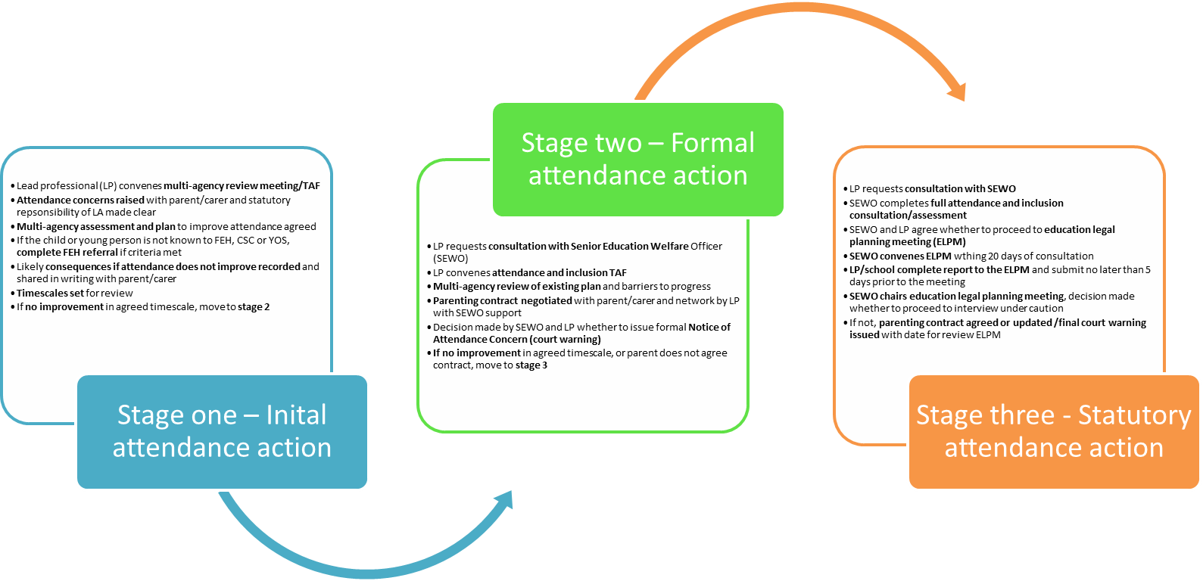
Appendix 1
Flowchart – The three stage approach to managing attendance concerns
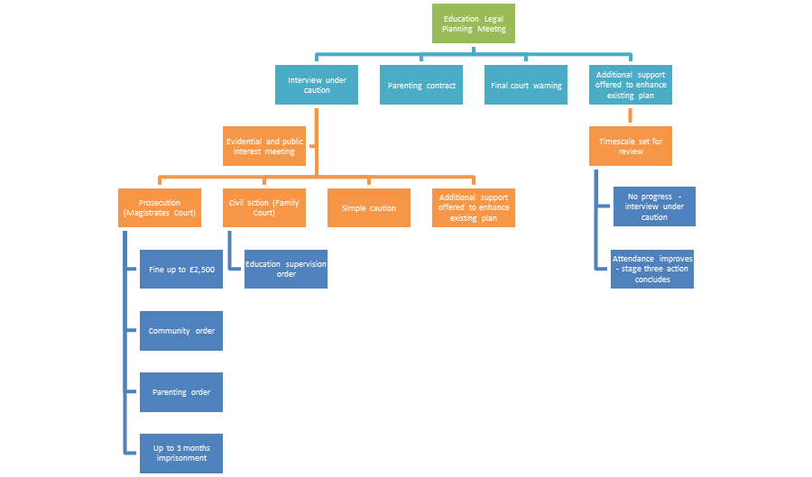
Appendix 2
Flowchart – Enforcement following education legal planning

